Capturing USB PD

Table of Contents
Background 1
Hardware used 2
USB Type-C™ Power supply 2
SparkFun Power Delivery Board - USB Type-C™ (Qwiic) 2
USB Type-C™ breakout 2
USB Type-C™ to USB Type-C™ cable 3
Connecting together 3
STUSB4500 4
SparkFun Power Delivery Board - USB Type-C™ (Qwiic) 5
Capturing communication 6
Biphase Mark Coding (BMC) 6
Capturing with oscilloscope 6
Capturing with data analyzer. 7
Analyzing protocol 7
Format 7
The pre-amble 8
The Start of package (SOP) 8
Message header 8
CRC and EOP 10
Capture Power Delivery in Saleae 14
Resources 15

Background

Given that the EU had decided to standardize on chargers based on USB Type-C™, I wanted to understand more about the USB Type-C™ power delivery (PD). I have read different documents about the USB Power Delivery (PD) standards, obtained a Sparkfun board and USB Type-C™ power supply. To analyse I have an oscilloscope and Saleae Logic 8 analyzer.

This document is not the one-size-have-it-all. It would mean a lot of copy / paste from many, many other documents, instead it shows how to create a setup to connect a power supply (source) and device (sink), to demonstrate the data that is flowing between them and how to analyse it.

Kind regards

Paul van Haastrecht

Hardware used

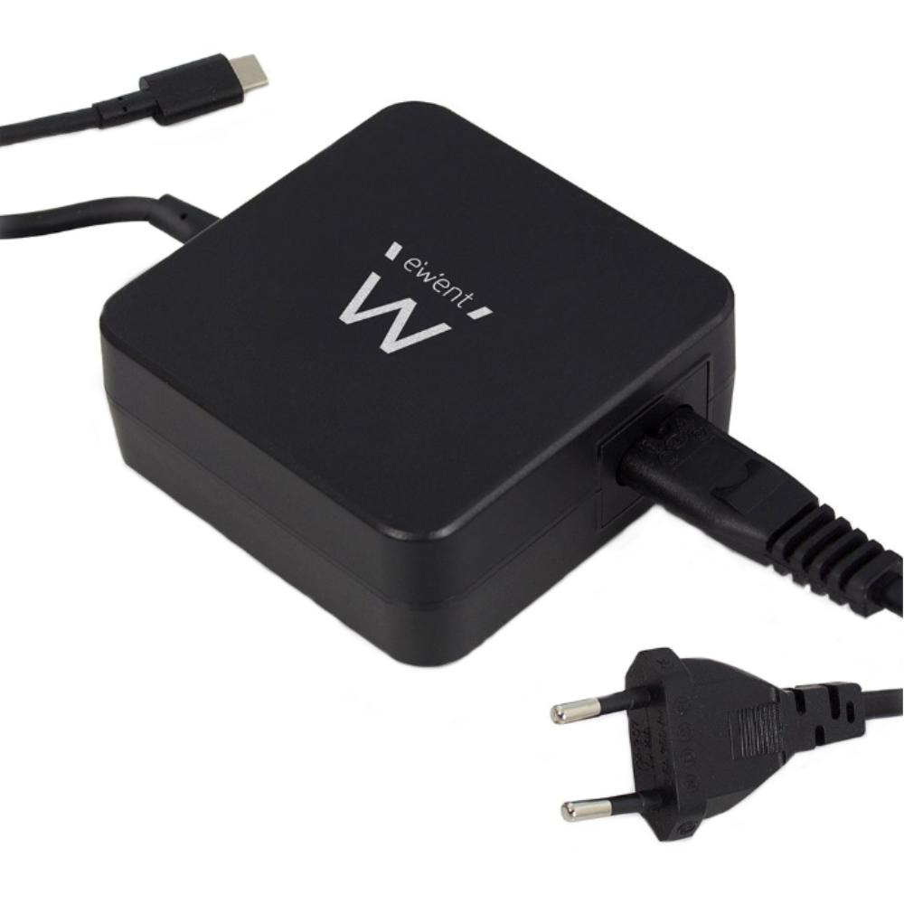
USB Type-C™ Power supply
There are many power supplies that have a USB Type-C connector, but that does not mean they support the USB Type-C™ PD profiles. As a result they will only provide the 5V. During this setup I have used an EWENT EW3980.

SparkFun Power Delivery Board – USB-C (Qwiic)
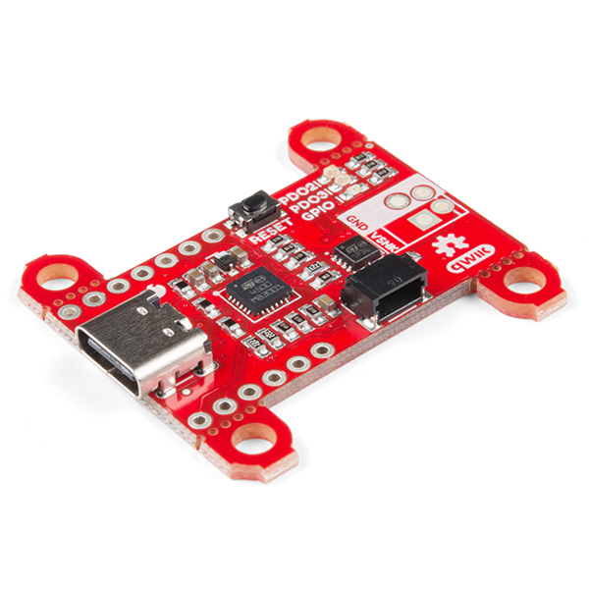
This Power Delivery board has an STUSB4500 chip which is able to handle the power delivery protocol as a sink (user).

https://www.sparkfun.com/products/15801

USB Type-C™ breakout
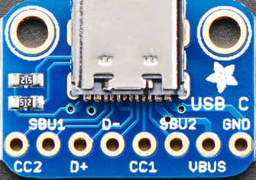
I decided to use the Adafruit USB Type-C break-out as that make the necessary lines available.

https://www.adafruit.com/product/4090

This breakout has the following connection points of the USB Type-C connector broken out.

Pin Function
GND Power Support for 60W minimum (combined with all VBUS pins)
VBUS Power Support for 60W minimum (combined with all VBUS pins)
SBU2 Alternate Mode Lower speed side band signal
CC1 Connection control line
D - Data line USB2.0
D+ Data line USB2.0
SBU1 Alternate Mode Lower speed side band signal
CC2 Connection control line
This is NOT the complete set of pins available in a USB Type-C plug. A complete description of a USB Type-C on a number of places online (e.g. http://ww1.microchip.com/downloads/en/appnotes/00001953a.pdf)

USB Type-C™ to USB Type-C™ cable

For the USB-Power Delivery (PD) you will need a USB Type-C™ cable between the USB Type-C breakout and the Sparkfun board. I have made sure to have a USB Type-C™ data cable as these have D+ and D- connection as well (although not used during this setup). Also be aware the as part of the USB Type-C™ protocol these cables CAN have the capability to communicate to provide additional information about the cable type (e.g. the maximum power etc). However that is optional and not used in this setup.

Connecting together

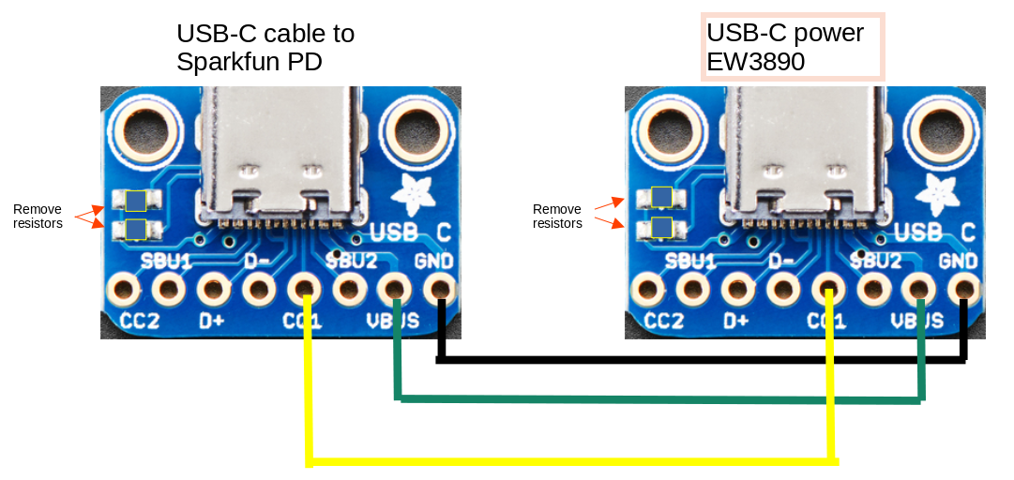
IMPORTANT :
You have to remove two 5.1K resistors on the boards as these resistors are connected to the CC1 pins and indicate to the upstream port to provide 5V and up to 1.5A. The Sparkfun board will take of that.

During this test I have only connected GND, VBUS and to CC1 between the breakout. In my case the CC1 line was used, maybe in your case the CC2 line needs to be used. All depends which way around you connect the USB-C connectors.

STUSB4500
(Source : the datasheet)

The STUSB4500 is a USB Type-C™ and power delivery controller IC for sink applications. It is able to negotiate a power delivery contract with a source without MCU support (auto-run mode). It relies on proprietary algorithms and configurable PDO (power data objects) thanks to an integrated non-volatile memory. It supports dead battery mode to allow a system to be powered from an external source directly. Combined with its capability to negotiate directly a power contract, the STUSB4500 is the ideal controller device for autonomous systems requiring high power charging profile to be fully operational.

The STUSB4500 major role is to:
- Detect the connection between two USB Type-C ports (attach detection)
- Establish a valid source-to-sink connection
- Determine the attached device mode: source or debug accessory
- Resolve cable orientation and twist connections to establish USB data routing (MUX control)
- Negotiate a USB power delivery (PD) contract with a PD capable source device
- Configure the incoming VBUS power path and the charging paths accordingly
- Monitor the VBUS power path and manage the VBUS voltage transitions
- Handle the high voltage protections

The STUSB4500 also provides:
- Dead battery mode
- PDO (power data object) customization through NVM
- Internal and/or external VBUS discharge paths
- Dual high power charging path support
- Debug accessory mode detection
- Customization of the device configuration through NVM to support specific applications

(source : https://github.com/USB-C/STUSB4500)

By default, a USB Type-C port on your hardware can get only 5V from a USB-PD Power Source (Host / DFP) This product enables to automatically negotiate a higher voltage from the source (>5V) up to 100W (20V@5A).
For instance, if the power brick can provide 4 power profiles (5V, 9V, 15V and 20V), then the STUSB4500 will request the highest voltage available (20V).
Another example, if the power brick can provide 4 power profiles (5V, 9V, 15V and 20V) but the Application needs 9V to boot, then the STUSB4500 can be programmed to always request 9V.
This part can be easily implemented in a battery charger with USB Type-C™ input in the application.

The device doesn't need any software to run (it is autonomous), but it is possible to connect to this device by I2C to take control over the default device behavior, or to get the power information (Voltage/Current) of the attached power source at the other side of the cable.

SparkFun Power Delivery Board - USB-C (Qwiic)
(source : https://www.sparkfun.com/products/15801)

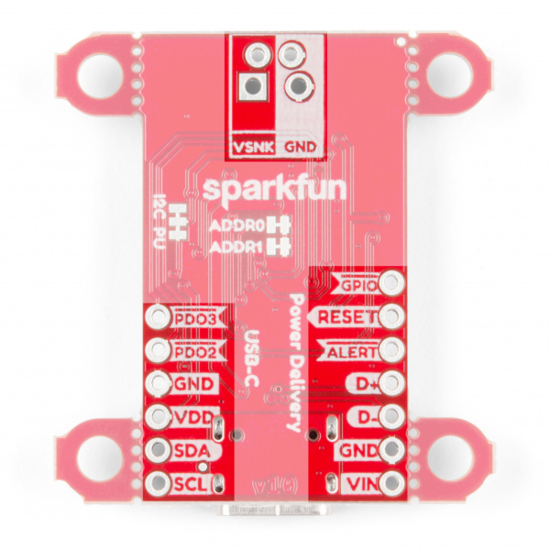
I decided for this board as it has the STUSB4500 chip. This can be programmed with a sketch connected over I2C. As the board has a Qwiic connector it is easy to connect to any of the Sparkfun boards that support this connector. Alternative the I2C is also available on header pins.
The STUSB4500 chip is very comprehensive. The 3 power data object (PDO) profiles, the different pins to provide output based on the conditions and some other USB PD parameters can be programmed. That can be set real time, e.g. when connected to an MCU, but also stored and remembered after reboot to work stand alone.
However it was challenge to understand exactly HOW, due to missing and/or scattered information. The datasheet is handling part, a programming manual another part and the non volatile memory (NVM) is a described in other documents.
The datasheet is mostly about the pins and the interfacing options, the programming manual about the real-time registers and the NVM documents on how to read the stored information and update the different sectors. I would advice to read all these documents and be patient
Sparkfun has created a library that can handle much of it: https://github.com/sparkfun/SparkFun_STUSB4500_Arduino_Library.
It has a number of good examples to read and update the data in the registers and in the NVM.
Next to this library there are a number of github sites that can be used for alternative or reference.

Capturing communication

Biphase Mark Coding (BMC)
(source: Part of text / descriptions is sourced from USB PD R3.1 V1.5 2022-07.pdf)

Biphase Mark Coding (BMC) is the physical layer Signaling Scheme for carrying USB Power Delivery Messages. This encoding assumes a dedicated DC connection, identified as the CC wire, which is used for sending PD Messages. The frequency is ~150Khz
Biphase Mark Coding is a version of Manchester coding (see [IEC 60958-1]). In BMC, there is a transition at the start of every bit time (UI) and there is a second transition in the middle of the UI when a 1 is transmitted. BMC is effectively DC balanced, (each 1 is DC balanced and two successive zeroes are DC balanced, regardless of the number of intervening 1’s). It has bounded disparity (limited to 1 bit over an arbitrary packet, so a very low DC level).

Capturing with oscilloscope
This is as good as impossible to capture and very difficult to analyze. Below a screenshot. What you can see is that the voltage level is about 1.2V.

Capturing with data analyzer.
I have a Saleae Logic 8 which is a great tool to analyse different protocols. On the web I found instructions on how to set the Saleae software to capture and display the protocol data on the CC1 line (see chapter: Capture Power Delivery in Saleae)
While this is one stream of data, I have copied past it in parts. On the first picture you see also the analog signal (A0), about 1.2V. It is just to show it once. Actually also the hex values (0xAA, 0x18, 0xE3 etc) have no good meaning you need to watch the zero’s and ones. Each 5 BMC- bits, make 4 data-bits. Hence I have changed that. (edit analyzer and display binary)
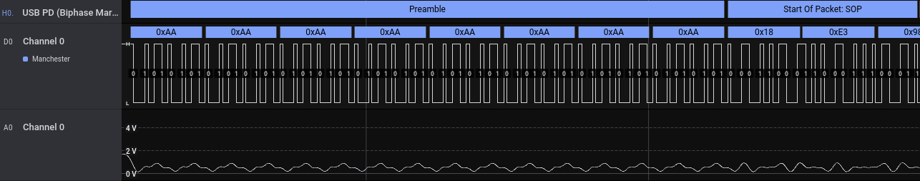

Analyzing protocol
Part of text / descriptions is sourced from USB PD R3.1 V1.5 2022-07.pdf

Format
The formats of a packet can be as follows :
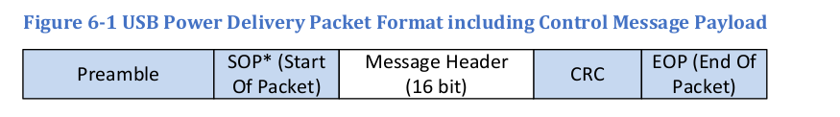
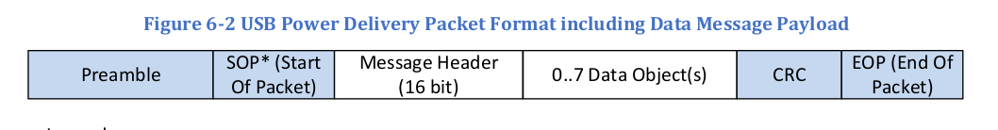
Also everything is LSB first (bytes and bits) in USB pd

The pre-amble
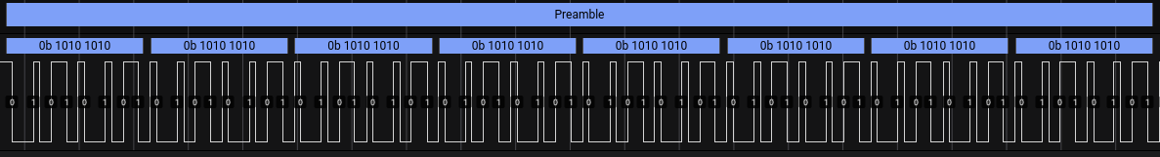
As defined by the protocol this is NOT BMC. The Preamble Shall consist of a 64-bit sequence of alternating 0s and 1s. The Preamble Shall start with a "0" and Shall end with a "1"

The Start of package (SOP)
The SOP is indicating communication between the source and the sink. The SOP ordered set is defined as: three Sync-1 K-codes followed by one Sync-2 K-code. The SYNC-1 is defined as ‘11000’ in BMC coding and SYNC-2 ‘10001’
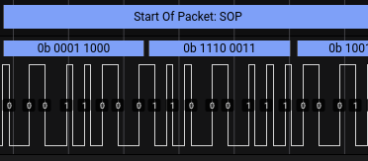
You can see clearly that everything is LSB first in USB pd.

Message header
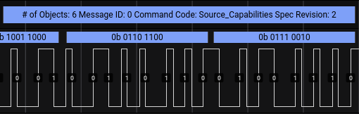
Instead of trying to become a manual decoder, I will rely of the work done by the analyzer. The header indicates there are six, 32- bit payloads in the package.

A Source Port Shall report its capabilities in a series of 32-bit Power Data Objects as part of a Source_Capabilities Message. Power Data Objects are used to convey a Source Port’s capabilities to provide power including Dual-Role Power ports presently operating as a Sink.
Each Power Data Object Shall describe a specific Source capability such as a Battery (e.g., 2.8-4.1V) or a fixed power supply (e.g., 12V) at a maximum allowable current. The Number of Data Objects field in the Message Header Shall define the number of Power Data Objects that follow the Message Header in a Data Message. All Sources Shall minimally offer one Power Data Object that reports vSafe5V. A Source Shall Not offer multiple Power Data Objects of the same type (fixed, variable, Battery) and the same Voltage but Shall instead offer one Power Data Object with the highest available current for that Source capability and Voltage.

So there are 6 objects that follow:

0xb01912c : Power data object, fixed supply
- Dual role Power: 0
- USB suspend supported: 0
- USB communication Supported: 0
- Dual Role Data: 1
- Unchecked Extended Messages Supported: 1
- Peak Current: 0
- Voltage (50mV units): 100 5 Volt
- Maximum current (10mA units): 300 3 Ampere

0x2d12c : Power data object, fixed supply
- Dual role Power: 0
- USB suspend supported: 0
- USB communication Supported: 0
- Dual Role Data: 1
- Unchecked Extended Messages Supported: 1
- Peak Current: 0
- Voltage (50mV units): 180 9 Volt
- Maximum current (10mA units): 300 3 Ampere

0x3c12c : Power data object, fixed supply
- Dual role Power: 0
- USB suspend supported: 0
- USB communication Supported: 0
- Dual Role Data: 1
- Unchecked Extended Messages Supported: 1
- Peak Current: 0
- Voltage (50mV units): 240 12 Volt
- Maximum current (10mA units): 300 3 Ampere

0x4b12c : Power data object, fixed supply
- Dual role Power: 0
- USB suspend supported: 0
- USB communication Supported: 0
- Dual Role Data: 1
- Unchecked Extended Messages Supported: 1
- Peak Current: 0
- Voltage (50mV units): 300 15 volt
- Maximum current (10mA units): 300 3 Ampere

0x5f156 : Power data object, fixed supply
- Dual role Power: 0
- USB suspend supported: 0
- USB communication Supported: 0
- Dual Role Data: 1
- Unchecked Extended Messages Supported: 1
- Peak Current: 0
- Voltage (50mV units): 380 19 Volt
- Maximum current (10mA units): 342 3.42 Ampere

0x64145 : Power data object, fixed supply
- Dual role Power: 0
- USB suspend supported: 0
- USB communication Supported: 0
- Dual Role Data: 1
- Unchecked Extended Messages Supported: 1
- Peak Current: 0
- Voltage (50mV units): 400 20 Volt
- Maximum current (10mA units): 325 3.25 Ampere

Funny enough is the 19 Volt / 3.42A NOT a documented option for this power supply. It only documents the other 5. So why ???

CRC and EOP
It is a documented limitation of the USB-PD analyzer, that it does not handle CRC.
As the end of the package you find ‘1011’ which is the End Of Package (EOP) in ‘1101’ with LSB of the EOP first.

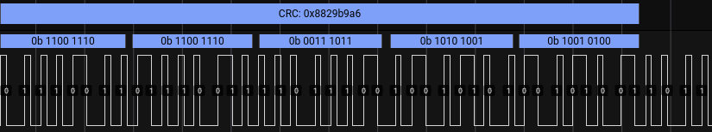

Let’s have a look at what the source capabilities mean.

Since all USB Providers support vSafe5V, the required vSafe5V Fixed Supply Power Data Object is also used to convey additional information that is returned in bits 29…23. All other Fixed Supply Power Data Objects Shall set bits 29…23 to zero. So the first object is providing more information in the 32 bits :

0xB01912C : Binary : 0000 1011 0000 0001 1001 0001 0010 1100
bits 31,30 00 fixed power supply
bit 29 0 dual role
bit 28 0 USB Suspend Supported
bit 27 1 Unconstrained Power (connected to AC)
bit 26 0 USB Communications Capable
bit 25 1 Dual-Role Data
bit 24 1 Unchunked Extended Messages Supported
bit 23 0 EPR Mode Capable
bit 22 0 reserved
bit 21,20 00 peak current
bit 19,10 0001 1001 00 voltage is 50mV units (0x64 = 100)
bit 9,0 01 0010 1100 ampere in 10mA units (0x12c = 300)

So the next packages will only use the bits 0 – 22. Looking at object 6 for example.
0x64145 Binary : 0000 0000 0000 0000 0110 0100 0001 0100 0101
bit 31 – 23 0000 0000 0000 0 forced to zero
bit 22 0 reserved
bit 20,21 00 peak current
bit 19,10 0110 0100 00 voltage in 50mV units ( 0x190 = 400)
Bit 9,0 01 0100 0101 Ampere in 10mA units (0x145 = 325)

Now the sink (STUSB4500) has received the source capabilities and checked that the CRC on the received package is matching his calculation. It will let the source know that it received a good package:

Preamble + SOP
[0x161] # of objects: 0 Message ID:0 Command Code : GoodCRC spec revision: 1 (*1)
CRC +EOP

(*1) changed the original USB_PD a little to show the decoded data / bits.

0x161 : Binary 0000 0001 0110 0001

bit 15 0 extended header
bits 14,12 000 number of objects
bits 11,9 000 message ID
bits 8 1 port power role (set to source)
bits 7,6 01 revision specification
bits 5 1 port data role (DFP = down facing port = sink)
bit 4,0 0 0001 message type (GoodCRC)
I had the STUSB4500 PDO3 set to 20V / 3 Ampere, so we now see the request from the sink back to the source (power supply)

Preamble + SOP
# of objects:1 Message ID: 0 command Code : Request Spec Revision : 1
[0x60019145] Request Data Object (*1)
- Object position: 6
- Giveback flag: 0
- Capability missmatch: 0
- usb_communication_capable: 0
- no_usb_suspend: 0
- Unchunked_extended_messages_supported: 0
- Operating_current_10ma_units: 100
- maximum_Operating_current_10ma_units: 325
CRC + EOP

(*1) changed the original USB_PD a little to show the decoded data / bits.

0x60019145 : Binary 0110 0000 0000 0001 1001 0001 0100 0101

bit 31,28 0110 Object position (6)
bit 27 0 Giveback
bit 26 0 Capability Mismatch
bit 25 0 USB Communications Capable
bit 24 0 No USB Suspend
bit 23 0 Unchunked Extended Messages Supported
bit 22 0 EPR Mode Capable
bit 21, 20 00 reserved
bit 19,10 0001 1001 00 Operating current in 10mA units (0x64 = 100)
bit 9, 0 01 0100 0101 Maximum Operating current in 10mA units (0x145 = 325)

Now that the request has been sent, time for the source to let know that it received a good package:

Preamble + SOP
# of objects: 0 Message ID:0 Command Code : GoodCRC spec revision: 1
CRC + EOP

The source is now confirming the request. It has increased his message ID count:

Preamble + SOP
# of objects:0 Message ID: 1 command Code : Accept Spec Revision : 1
CRC + EOP

Time for the STUSB4500 to tell it get the message ID 1 with good CRC :

Preamble + SOP
# of objects: 0 Message ID:1 Command Code : GoodCRC spec revision: 1
CRC + EOP

The source is now letting know that it is ready to supply, again increase the message ID:
Preamble + SOP
# of objects: 0 Message ID:2 Command Code : PS_RDY spec revision: 1
CRC + EOP

Time for the STUSB4500 to tell it get the message ID 2 with good CRC
Preamble + SOP
# of objects: 0 Message ID:2 Command Code : GoodCRC spec revision: 1
CRC + EOP

WE ARE IN BUSINESS NOW !

Capture Power Delivery in Saleae
(source : https://github.com/saleae/hla-usb-pd)
Select the Manchester decoder, edit and set as FM1, sample 300000.

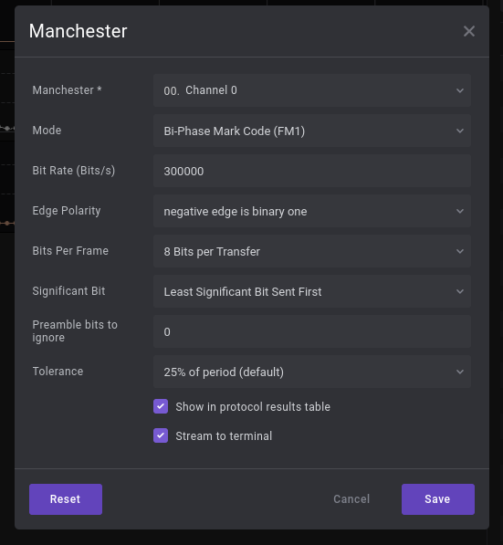

Add the USB PD (biphase Mark Code) analyzer from the list
edit and select Manchester decoding
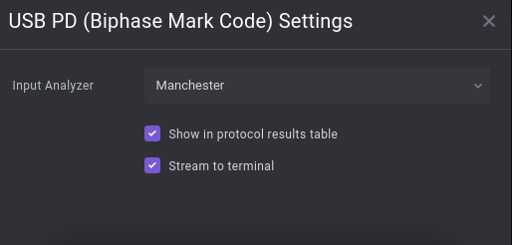

Resources

USB PD (biphase Mark Code) analyzer. info https://github.com/saleae/hla-usb-pd
Adafruit USB Type-C™ breakout https://www.adafruit.com/product/4090

